So first what is a Service Worker? Well, you can kind of think about it as a standalone JavaScript program that you can run in your browser. This Service Worker can handle background/network tasks for your website/app. Why would this be useful? Well with Service Workers we can have excellent grain control of our outgoing and incoming network requests as well as our browser cache.

We can think of our Service Worker as a middleman between our app and the network. With this control, we can programmatically control how our app should respond to specific network situations. What should we do if the app is offline? Use cache? If we do have a connection, we can tell the app always to use cache on certain static assets. We can even create scenarios such as using the network first and if that fails to fall back to the cache. We get a lot of flexibility in controlling our apps behavior with the network. Service Workers allow us to explicitly tell the browser what to do in situations of low to no connectivity instead of seeing this:

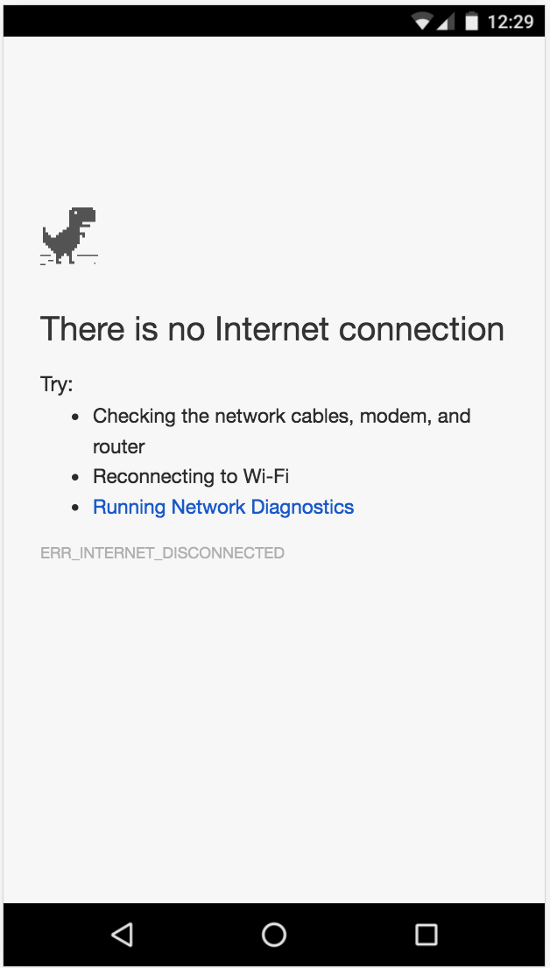

I won’t go into all the specifics of the Service Worker API and all the offline patterns, but I highly recommend reading Jake Archibald’s fantastic [Offline Cookbook](https://jakearchibald.com/2014/offline-cookbook/). We will cover more of the ideas of the Service Worker as we go along.